**National University of Computer & Emerging Sciences**

**Karachi Campus**

**Project Report**

**Psychology**

**Section: BCS-3D**



**Teacher: Miss Shahtaj Shakir**

**Structure Of Personality by Sigmund Freud**

**Group Members:**

**21k-4556 Muhammad Anas**

**21k-3298 Owais Ali Khan**

**21k-3263 Uzair Shehzad**

**21k-4576 Hussain Malik**

**21k-4513 Hamza Iqbal**

Data Of Submission:

15-NOV-2022

**Intro**

Freud was a Viennese physician who thought his patients’ problems were more emotional than physical​.Freud began his work by using hypnosis and eventually switched to psychoanalysis​.He had many followers: Jung and Adler, to name a few​.

Freud used cocaine and tobacco and died from oral cancer​. More than 100 years later, his work is still influential and very controversial​.

Freud asserts that we are motivated by psychosexual forces​. Childhood experiences and unconscious motivations determine our adult thoughts and behaviors.​We are captives of our biological and environmental forces.​

The 3 personalities in a person are the id, ego, and superego.​

Id - the deep unknown force inside us wanting pleasure.​

Superego – the parental voice and values that govern thought.​

Ego – the mediating manager.​

According to Carl Jung, our personality is decided

by the past and what we hope to become.  He gave a greater role to the ego.​

According to Eric Erikson, there are 8 stages of psycho-social forces that motivate us and determine if we grow or not. Those are as follows :​

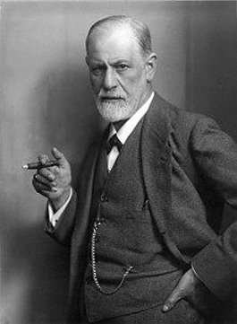Trust vs. Mistrust​

Autonomy vs. Shame​

Initiative vs. Guilt​

Industry vs. Inferiority​

Identity vs. role confusion

​

Intimacy vs. Isolation​

Generativity vs. Stagnation

​

Integrity vs. Despair​

​

​

These stages, if satisfied, move us to the next stage or we will stagnate and live in misery if we don’t satisfy them.

**Level of Awareness​**

The conscious mind involves thoughts that someone is aware of at any given moment.​

 The preconscious mind involves things that can be brought into consciousness at any time.​

 The unconscious mind includes the thoughts and feelings that exist outside of one's conscious awareness.​

**Consciousness**

We ae conscious of both the external world and our internal selves

***But where does consciousness come from?***

Scientists’ theologians and philosophers have been trying to get to the bottom of this question for centuries without reaching any consensus one recent theory is that the consciousness is the brains imperfect picture of its own activity.

Conscious mind based on sensory inputs it builds models which are continuously updating simplified descriptions of objects and events in the worlds. Everything we know based on these models. They never capture every detail of the things they describe just enough for the brain to determine appropriate responses.

**Unconsciousness**

 In this theory, the unconscious refers to the mental processes of which individuals make themselves unaware.

In psychoanalytic terms, the unconscious does not include all that is not conscious, but rather what is actively repressed from conscious thought or what a person is averse to knowing consciously Unconscious thoughts are not directly accessible to ordinary introspection, but are supposed to be capable of being "tapped" and "interpreted" by special methods and techniques such as meditation, free-association (a method largely introduced by Freud), dream analysis, and 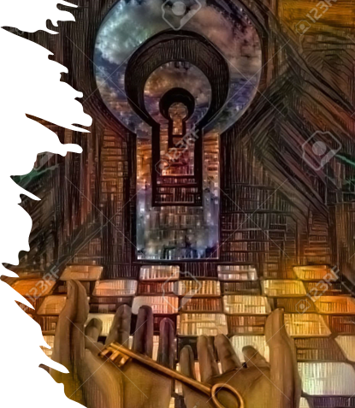verbal slips (commonly known as a Freudian Slip), examined and conducted during psychoanalysis.

Freud noticed that also his patient's dreams expressed important feelings they were unaware of. After these observations, he concluded that psychological disturbances are largely caused by personal conflicts existing at the unconscious level.

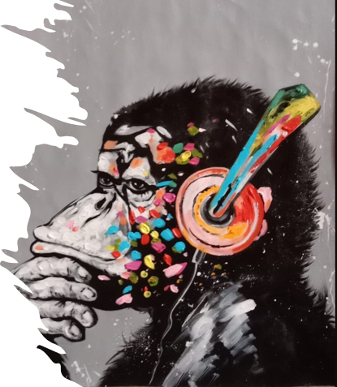**Preconsciousness**

The preconscious can also refer to information available for cognitive processing but that currently lies outside conscious awareness.  Freud introduced the notion that the unconscious mind is not merely used to describe the opposite of consciousness. Instead, he insisted that there exist two spheres in the unconscious: unconscious and preconscious He reserved the term unconscious for thoughts that are inadmissible to consciousness, while the term preconscious was used to denote the screen between the unconscious and conscious “If consciousness is then the sum total of everything of which we are aware, pre-consciousness is the reservoir of everything we can remember, all that is accessible to voluntary recall.”

**ID**



**DEFINITION**

The id is the only component of personality that is present from birth.

This aspect of personality is entirely unconscious and includes instinctive and primitive behaviors.

The id is very important early in life because it ensures that an infant's needs are met. If the infant is hungry or uncomfortable, they will cry until the demands of the id are satisfied. Young infants are ruled entirely by the ID.

**Characteristics of the Id**

The id exists in your unconscious, or outside of your awareness. Since the id is not part of your awareness, the desires of the id are not manipulated by experience or thought. The other personality components develop with age and experience, but the id never matures and continues to be driven by desire alone. The id does not think but only wants or acts. The characteristics of the id include:

* unorganized
* demanding and insistent
* illogical
* lacks morals
* instinctual
* selfish
* unconscious

The id is driven by what is called the pleasure principle, the idea that your needs should be met immediately. When you are hungry, the pleasure principle directs you to eat. When you are thirsty, it motivates you to drink. Tension results when you do not receive instant gratification of all your needs or wants. The id cannot tolerate this tension and puts more pressure on you to satisfy your desire and relieve the tension. This is when other components of your personality come into play.

**EGO**

The ego is 'that part of the id which has been modified by the direct influence of the external world.

It is the decision-making component of personality.

The ego operates according to the reality principle, working out realistic ways of satisfying the id’s demands

The ego considers social realities and norms, etiquette, and rules in deciding how to behave.

***Why learn ego?***

Understanding our ego states helps us to understand:

***Who am I?***

***Why do I act the way I do?***

***How did I get this way?***

It is a method of analyzing a person's thoughts, feelings and behaviors based on the phenomena of ego states.

There are three ego states:

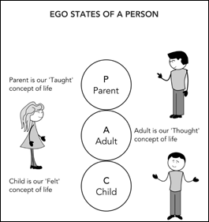

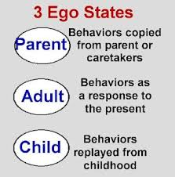

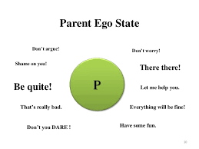**Parent ego state**

When people act, think, or feel as their parent/caregivers once did, they are in the Parent ego state.

For example:

If you have seen your father smoking cigarettes, then after certain age you also start smoking you are now in your Parent ego state**.**

**Adult ego state**

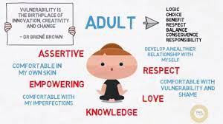When a person is acting based on facts, rather than based on parental tradition or childhood feelings, they are in the adult ego state.

For example:

When choosing career, a person may look at different opportunities and education and decide according to the need (here and now decision) rather than go with the career chosen by his parents (tradition).

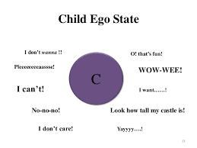**Child ego state**

It contains all natural feelings, needs, impulses, and potentialities of an infant.

It also contains creative, manipulative, intuitive capacities as well as feelings and behaviors learnt during childhood like compliance, procrastination, and anger.

*How is child ego state triggered?*

When a cue in the present environment reminds our body or mind of the past traumatic event, this creates the perfect circumstance for an ego state (also known as part of self) to activate.

**Superego**

In Sigmund Freud's psychoanalytic theory, the superego is the third and most recent of the three agencies that make up a person's personality. The superego, which makes up the ethical part of the psyche, gives the ego the moral guidelines by which to conduct itself. The superego's judgments, restrictions, and restraints serve as one's conscience, while its lofty goals and ambitions serve as one's idealized self-perception, or "ego ideal."

The superego grows in reaction to parental criticism and approval during the first five years of life. This growth results from the youngster internalizing his parents' moral principles, a process that is considerably facilitated by a propensity to identify with the parents. The growing superego serves to restrain violent or other socially inappropriate urges by assimilating family and social norms. When the superego's ideals are broken, one experiences remorse, worry, and a desire to make amends. As a person meets other admirable role models and adjusts to the laws and standards of the broader society in their early adult years, their superego continues to grow.

***Is it possible to break through a strong Superego ?***

It requires a lot of effort, but it is possible to transform from a critical to a supportive superego.

The harsh superego is skilled at influencing us in a variety of unconscious ways, so doing this work alone may be extremely challenging. Any form of long-lasting change necessitates awareness and work carried out in a supportive therapeutic environment.

**1. Practice at Home**

Awareness is the main source of transformation. Your ability to alter the harsh superego increases as you become more conscious of it. You can use several methods at home that are frequently beneficial.

Like doing 5–10 minutes of meditation each day. Keep your attention on your breathing while keeping an eye out for any emergencies of the harsh superego.

**2. Psychotherapy: A Healing Relationship**

In general, awareness alone might not be sufficient to bring about long-lasting change. Here, psychotherapy and psychoanalysis are frequently beneficial. A psychotherapist or psychoanalyst can help identify the various ways the harsh superego can negatively affect a person by listening for its various forms.

The therapist's attitude toward this investigation, however, is much more therapeutic than teaching. A caring and empathic therapist can be internalized over time, just like a patient and loving father, taking the place of the critical superego. It could take some time and patience, but it's doable.

**Being used in Several therapy techniques**

Therapy techniques which use the idea of the unconscious mind to treat patients. The current habits and behaviors of patients might be influenced by what happened to them in childhood. Those memories are stored in their unconscious mind.

The patients are allowed to talk freely about their innate desires, dreams and at random without the constraints of their conscious mind. The very early life of patients, and their relationship with their primary caregivers is also studied.

Adult problems are traced back to childhood. Repressed painful memories emerge. It is discovered that which of the current behaviors, thought patterns and insecurities have their roots in the unconscious mind

Once those roots emerge, the current problems are treated accordingly.